# KLOVE Employee Management Site

Created 5/1/2019

by Ray Diaz

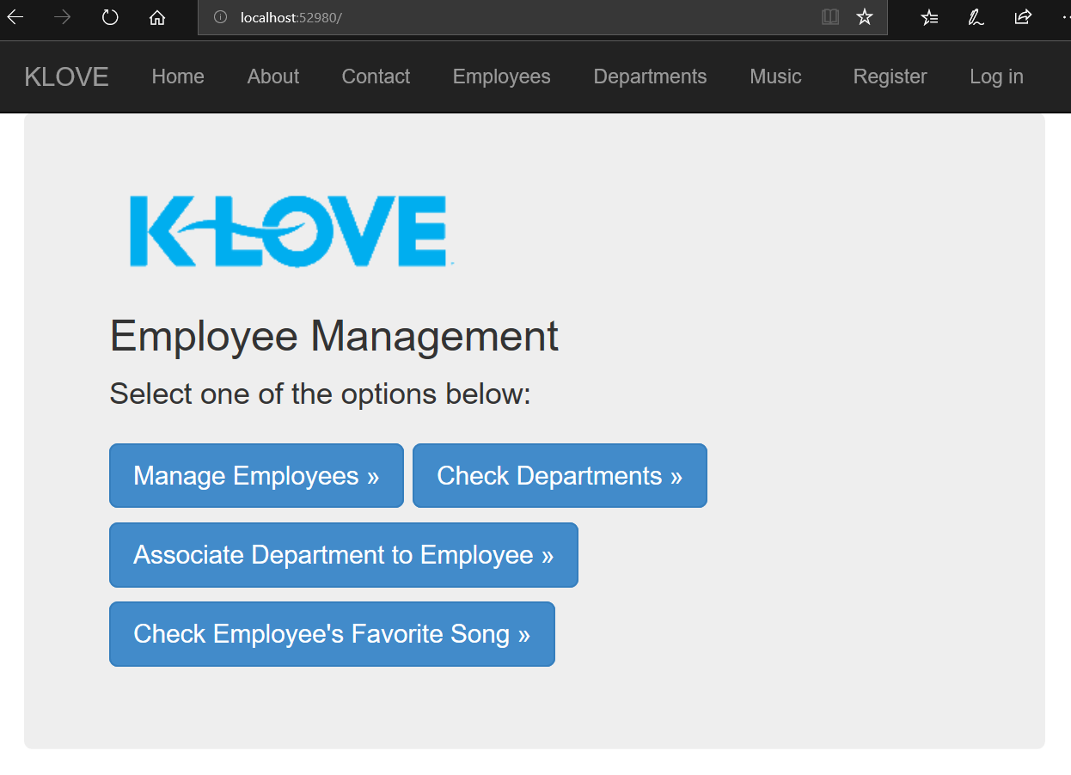

# Instructions for Install

1. From GitHub, retrieve the KLoveEmployeeManagement split zip files to a local staging location, like C:\temp.

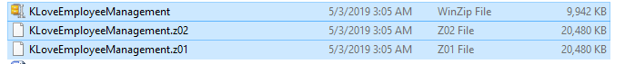

1. Open just the first zip file “KLoveEmployeeManagement.zip”, and follow the options to unzip all the files to the staging location. When unzipped, you will have a folder named “KLoveEmployeeManagement” with these subdirectories and files:

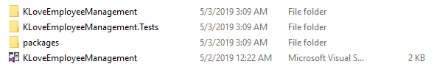

1. Retrieve the DBFiles folder from GitHub.
2. Note, the main database used has been backed up to a file called “KLoveDB.bak”.
3. Restore the database into SQL Server using the KLoveDB.bak file. Note: I used Sql Server Express.
4. In the folder .\KLoveEmployeeManagement\KLoveEmployeeManagement, change the connection string in web.config to point to your instance of SQL Server.
5. Build the app in Visual Studio (Note: I used Visual Studio 2017) and run the app on your browser.

**Note:** Users cannot get into About or Contact menu unless they register first through the “Register” menu on the top right. This was added so that the user can use the Register and Login features of the site.

# Packages/Software Used

Visual Studio 2017

Dot NET Framework 4.6

Entity Framework version 6.1.3

MVC5

Razor

Used SqlExpress, localdb.

EntityFramework 6.2

Web Essentials

Power Tools

Google Chrome (73.0)

IE11

# Database Connection

If needed, this is the one I used:

Data Source=DESKTOP-UUVG9DU\SQLEXPRESS;Initial Catalog=KLoveDB;Integrated Security=True;User ID=test;Password=test;

# Domain Model

Employee

Departments

Music

# Notes

We have included a SQLQuery1Inserts.sql file to be able to re-add the db data in case it was accidentally erased, as well as the Department, Employee, and Music create sql, in case the database was lost. These are located in the DBFiles folder.

Please email me at [raydiaz3000@gmail.com](mailto:raydiaz3000@gmail.com) or call 262-422-3902 if you are unable to install and run the app. Thank you!